ADS Part 3
Sorting Algorithms
So far, worst case running time either O(n²) (Selection, Insertion Quick) or O(nlogn) (Merge sort)
It is provable that for any comparison based sorting algorithm A and any n large enough, there exists an input of size n such that A has to be Ω(nlogn)
- This only applies to comparison based sorting algorithms
- There exists an input – only has to be one input of length n, not necessarily for all inputs of length n.

Suppose values in the list can repeat but have a constraint, e.g. have to be between 0 and 9. Is it possible to have an algorithm better than O( nlogn )?
Yes, but does not involve comparisons.
Bucket Sort
You are to sort n numbers, each taking a value in { 0, …, k-1}, any comparison based algorithm will have worst case complexity of O( nlogn) or worse, and do not care about the range of inputs.
Idea: start with k empty buckets, one for each number in the range of possible values. Scan the list and increment the counter in its respective bucket. In this algorithm, no comparisons are necessary.
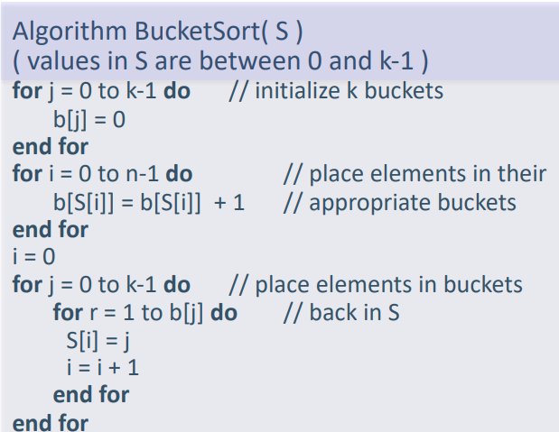
Algorithm:
If we were sorting values, each bucket is just a counter that is incremented whenever a value matching the bucket’s number is encountered. If we were sorting entries according to keys, we would enqueue entries into the relevant bucket (based on the key), and will be dequeued after the scan.
Time complexity:
Bucket initialisation is O(k), from array to buckets is O(n), from buckets back to array is O(n)
Time complexity O(n+k) – worst case. Usually k very small compared to n so just O(n).
If k = ω(n log n) then its worse than MergeSort
If k = ω(n²), then BucketSort is worse than any other comparison based algorithm.

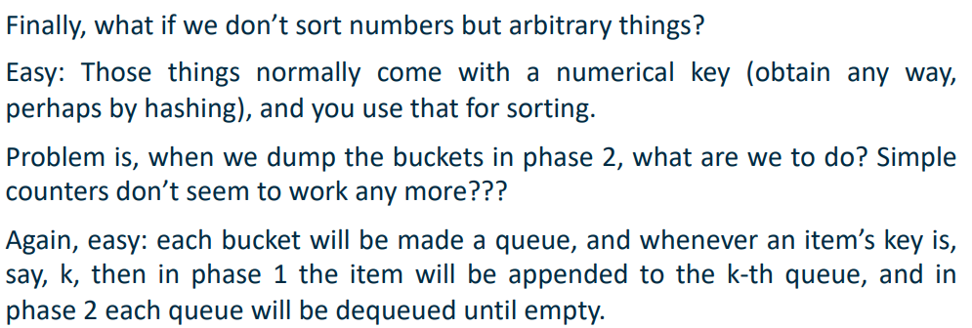
BucketSort can be peformed on any array of non-negative integers, with the number of buckets depending on the maximum integer value.
If we have 100 integers but max. value is 999999, time complexity is actually O(k) not O(n)

Radix Sort
Drawback of BucketSort -> if range of values is large we need a large number of buckets.
Improvement – do not look at item values but look “one level below”.
Consider again the subset of non-negative integers as range, and furthermore consider decimal representation.
Use this when keys are integers and there is a reasonable limit on their values. Number of passes depends on number of digits of maximum value (in decimal).
Idea: have as many buckets as there are different digits in the number base being used, i.e. 10 for base-10.
If maximum value is 999999, only 10 buckets needed not 1000000.
Repeatedly bucket sort by given digit, number of rounds (passes) depends on the largest value but number of buckets only depends on the number of digits in the number base.
Start with rightmost digit as leftmost digit is not known initially.
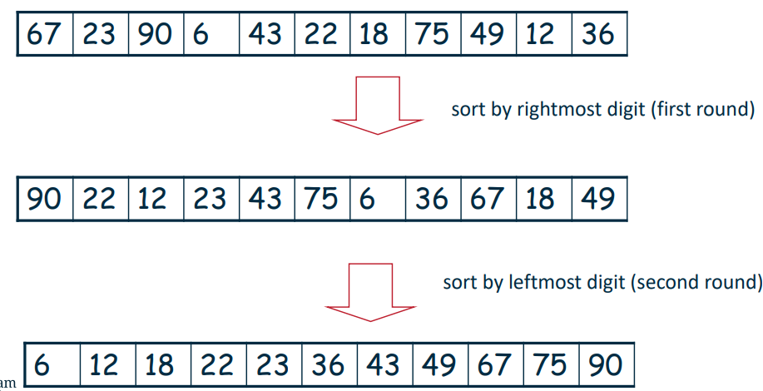
2 digit example:
A
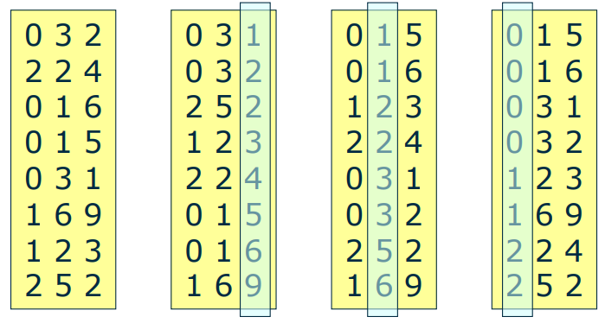
3 digit example:

RadixSort works if the BucketSort phases are stable, i.e. work done in previous rounds isn’t destroyed – if 43 occurs before 49 in the initial array, this should be preserved in the resulting array for a given phase.
Time complexity O( d n) where d is the number of digits (and hence the number of bucketSort stages).
Compared to BucketSort for range {0,…,k-1}:
RadixSort -> d = log₁₀k, giving O(n log k)
BucketSort -> O( n+k)
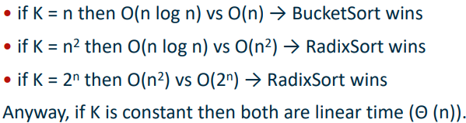
Which one is better depends on value of k. K usually constant, for this RadixSort better, but:
Note: RadixSort always better in terms of space.

Searching and Selecting
Searching
Suppose you have n numbers in a sorted array A [1…n] (this means the array is a stupid 1-indexed array, NOT that it contains all numbers 1 to n -> it contains any n sorted numbers)
Assume no 2 numbers in A are the same and that you are given a number x that is equal to one of the n numbers above.
Goal: devise an algorithm that finds the position, p, of x in A.

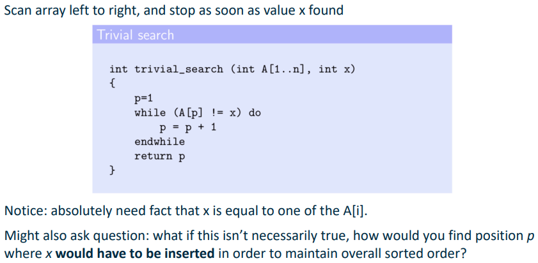
Trivial solution (linear search):

Binary Search:
- Peek right into the middle of the array at position p = n/2
- If A[p] = x then we are done and can return p
- Otherwise, if x > A[p], we recursively search the subarray to the right of A[p]. i.e. pass array A[p+1:] into the recursive call, since if x > A[p] it will be bigger than anything to the left of A[p]. Now our problem is smaller .
- Do opposite if x < A[p].

i.e. if the top level call was search (A, 1, n, x) and x > A[n+1/2] then the next call would be search(A,n+1/2 +1, n, x)
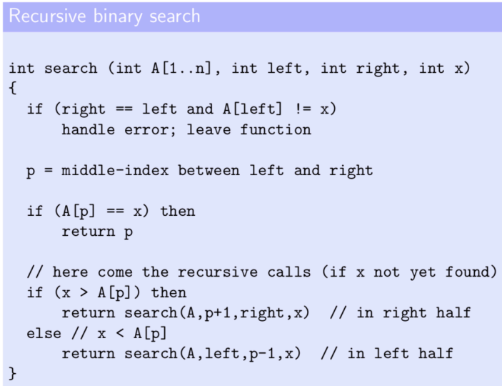
With every unsuccessful recursive call (i.e. doesn’t find the target element), the search space is halved – divide and conquer.
Complexity: linear search is O(n) whereas binary search is O(logn) -> recurrence T(n) + T(n/2) + O(1) = O(logn)
So far have assumed that input is sorted and were looking for the position p of a given value x.
If we change to an unsorted input and we are looking for the i^{th} smallest element -> this problem is called selection.
We can sort the input in O(nlogn) time and then return the i^{th} element from the left, however can we solve this quicker in the worst case?
QuickSelect
Same idea for selecting as QuickSort is for sorting.
- Recursive
- Partition function for selecting pivot and partitioning into LOW and HIGH (compared to pivot)
- Only one recursive call (not two like QuickSort).
After partitioning, we know the pivot is in the correct sorted position in the overall list. We can then recursively call QuickSelect on the HIGH or LOW list depending on whether the index i of the i^{th} smallest element is less than the index of the pivot.

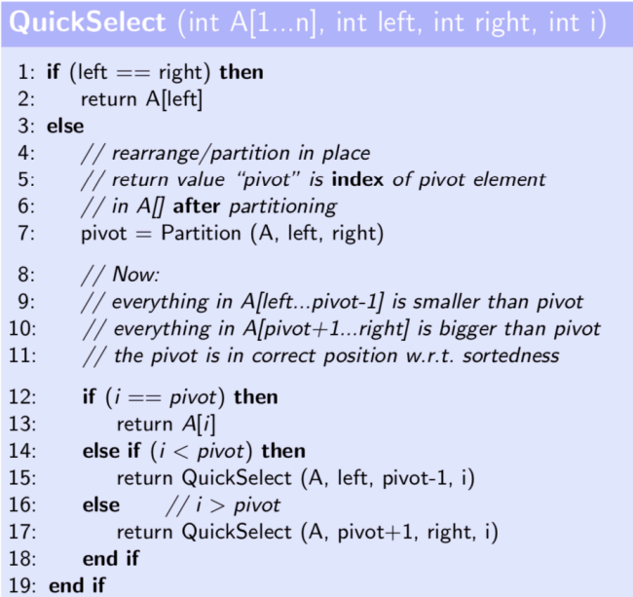
Performance of QuickSelect
If input already sorted, the recursive part will only reduce the problem by 1 each call. This results in O(n²) complexity.
However, choosing the pivot at random (randomised QuickSelect) results in an expected complexity of O(n).

Median of Medians Algorithm
Selection in unsorted data with worst case complexity O(n)
Can be thought of as QuickSelect with a good pivot selection strategy. Is doubly recursive (uh oh)
Has guaranteed O(n) complexity for finding the i^{th} smallest element in an unsorted list of n items.
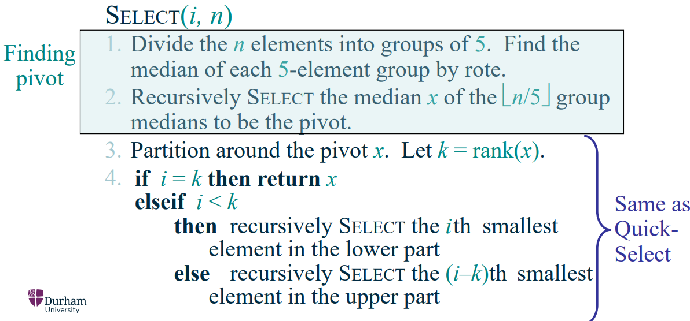
(rank(x) = index of x)
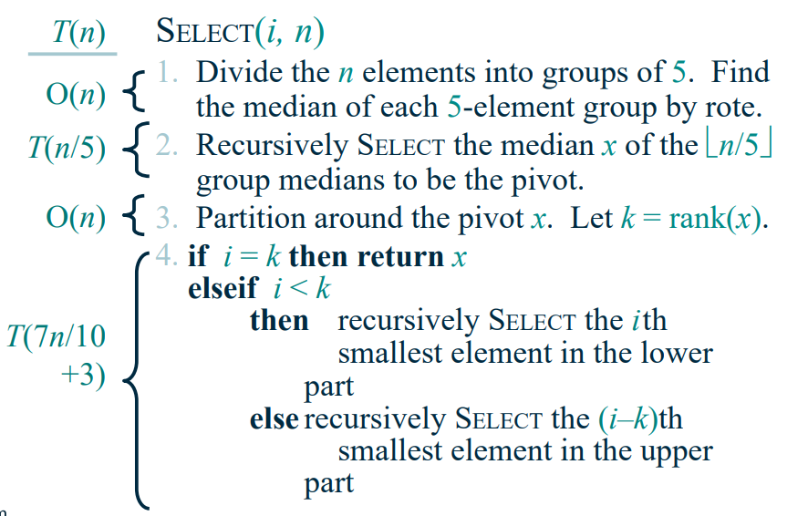
Complexity of Median of Medians:
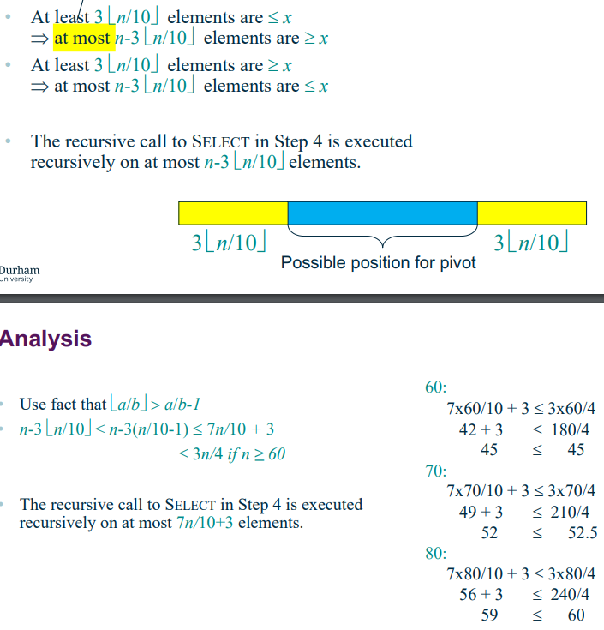
This is where the 7n/10 +3 comes from:

T(n) = T(1/5 n) + T(7/10 n + 3) + n
To show: T(k) <= ck for all k < n, n>0
Solving by substitution:
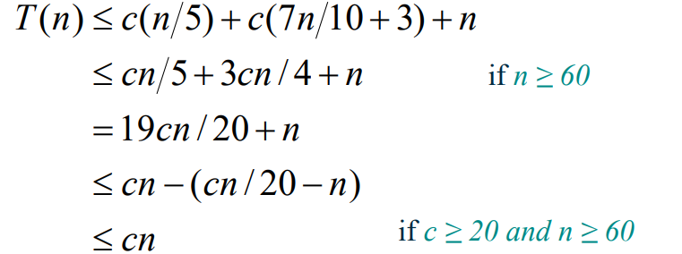
(apparently)
Compared to QuickSelect:
- QS singly recursive, so less work per iteration than MoM
- QS can have more iterations if we are unlucky with pivot selection.
- In practice, choice of selection algorithm depends on circumstances. – randomised QS often used, as its bad behaviour is rare and tolerable
- MoM used if good behaviour is absolutely needed in all cases.

Trees
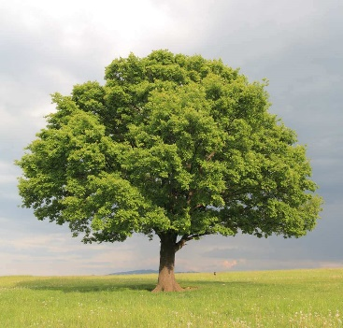
A tree whose elements have at most two children is called a Binary Tree
Since each element can have only 2 children, these are called the left and right children
Rooted trees have one node as the topmost node. All other nodes are descendants of the root.
Elements at the bottom of the tree, i.e. with no children, are called leaves.

Every node excluding the root is connected by a directed edge from exactly one other node.
Edge – the link from one node to another
Siblings – two nodes that have the same parent
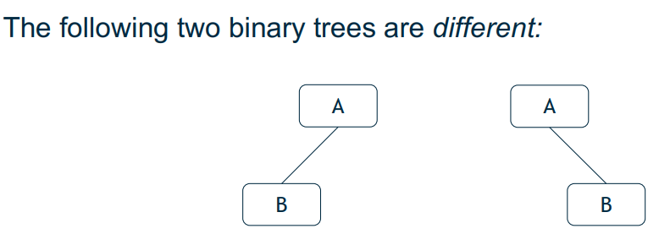
Path length – the number of edges that must be traversed to get from one node to another.
The first tree has a left child but no right child, the second tree has a right child and no left child.
The size of a binary tree is the number of nodes it has.
The depth of a node is its distance from the root.
A proper binary tree is one where all nodes either have two or zero children.
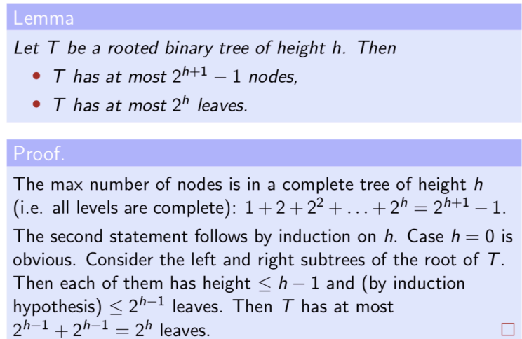
Why do we have to introduce maths???

Binary trees can be used to represent arithmetic expressions
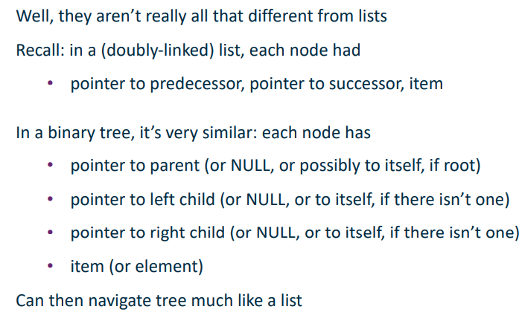
Binary trees can also be used to store data. Why?
Binary trees are very useful for storing data- fast insert, lookup and delete operations (dictionary operations).
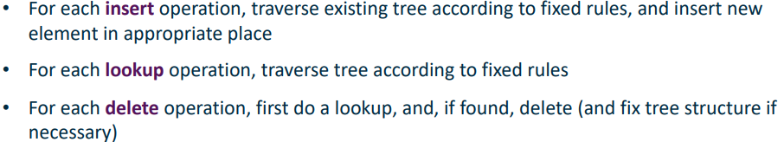
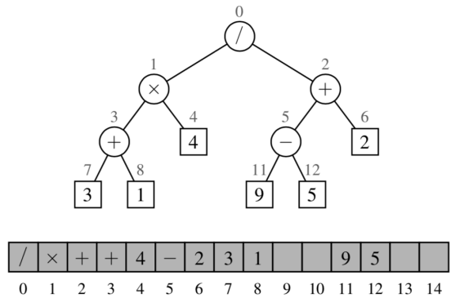
Can also represent binary trees using an array.
However, some update operations for trees cannot be efficiently supported, e.g. deleting a node and moving its child up takes O(n) time as all the child’s children also need to be moved in the array.
Searching a binary tree:
- Start at the root
- Search level by level until you find the element you are searching for or reach a leaf. This is O(n), similar to searching a linked list, as we have to check every element.

Binary Search Tree (BST):
A BST is a tree in which no node has more than two children (as with binary trees). They also have an important invariant (property): For all nodes, v, of the tree, it is always true that all elements in v’s left subtree are less than v, and all elements in v’s right subtree are greater than v. This property must be maintained when insertions, deletions etc are carried out.
Tree Traversals:
Traversing a tree involves visiting each node exactly once. Tree traversals are recursive. Since a BST has 3 parts (node, left, right), there are 6 different possible ways to traverse the tree
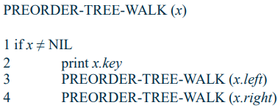
Pre-order traversal: root – left – right
(who tf uses NIL instead of NULL ???)
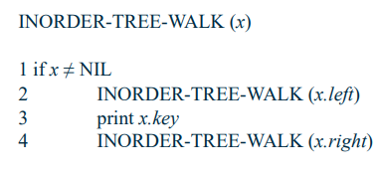
In-order traversal: left-root-right
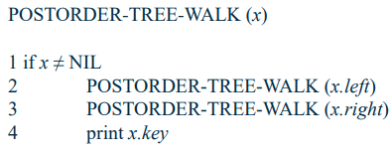
Post-order traversal: left-right-root

Note for a BST, in-order traversal gives the elements in sorted order.
BST also does not contain repeated values.
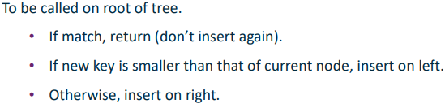
Inserting into a BST:
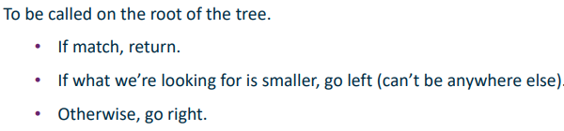
Searching a BST:

Deleting from a BST:
- Most difficult of the dictionary operations (insert, search, delete) on BSTs
- First perform a lookup to check if the element we wish to remove is in the tree. If it is not, we are done.
- If the node is a leaf then we can just remove it.
- If the node has one child, then we can remove it and replace it with the child.
- If the node to be deleted, N, has two children, we have to find the smallest node in the tree that is larger than N. We do this by going to N’s right child and recursively looking at the node’s left children until we reach a leaf. We then remove this leaf and move its value into the position of N. This is to remove N while maintaining the ordering of nodes within the BST.

See lecture slides for Python code for insert, search and delete from BST
BST complexity:
- Searching, insertions, deletions -> O(h)
- O(logn) -> average case
- O(N) in worse case, i.e. all elements on one side of the tree. Can be avoided by using balanced trees.
Balanced BSTs
h = O(logn) when BST is balanced -> good
h = Ω(n) if BST unbalanced -> bad
We want BSTs that do not degenerate (lose balancedness) when inserting and deleting without adding too much effort.
Basic rebalancing: rotations:
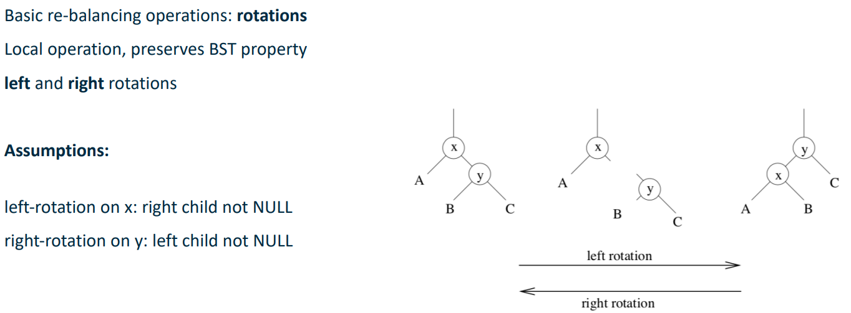
^ For left rotation: detach Y from X and B from Y. Attach X where B was and attach X where B was. For right rotation separate X from Y and B from X, reattach the other way around.
This operation modifies a constant number of parent-child links -> can be completed in O(1) time.
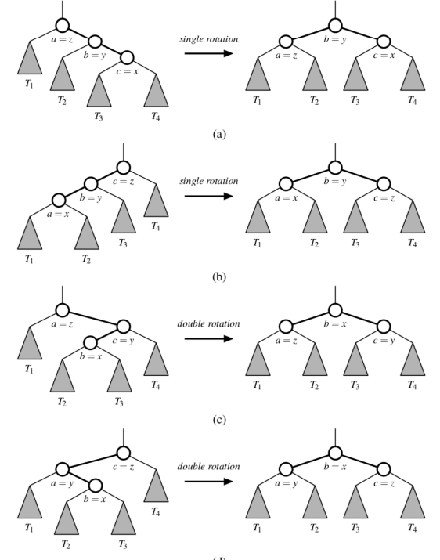
Simple rotations can be combined to provide rebalancing. Trinode restructuring = compound operation applied to parent-child-grandchild. This operation is also O(1).
<- The median of x,y,z always becomes the root of this subtree.

AVL Trees
An AVL tree is a self balancing BST such that for each node v, the height of v’s children differ by at most 1. Height is defined as: height of null = 0, height of leaf = 1, height of parent node = (max of the heights of its children) + 1
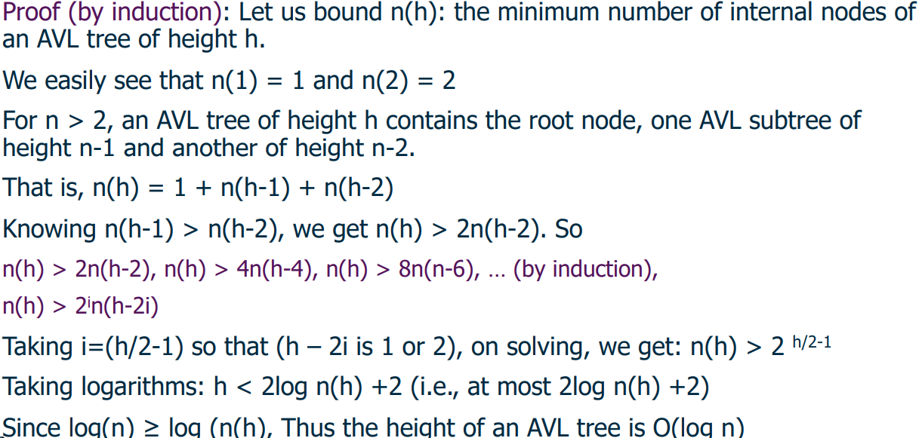
The height of an AVL tree storing n keys is O(log n)
Where n(h) is the MINIMUM number of nodes required to produce an AVL tree of height h (i.e. need to maintain the rule regarding any node’s children having height differing by at most 1).
E.g. n(3) = 4, n(4) = 7.

The standard BST operations take O(logn) time, but insertion and deletion can cause the height-balance property to be violated.
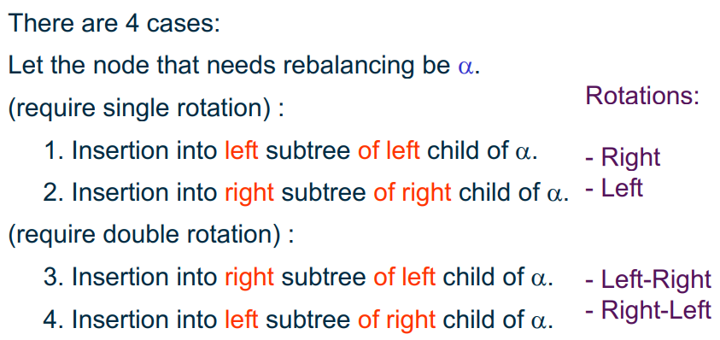

To fix imbalance after insertion:
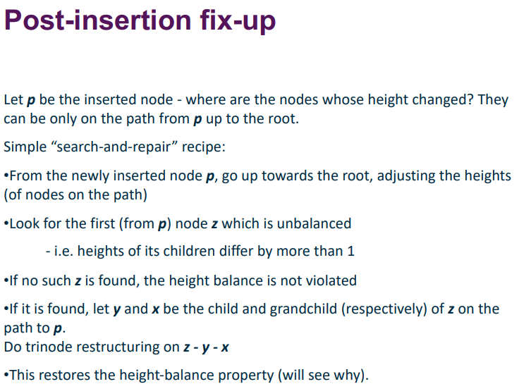
Complexity of Insertion – standard BST insertion in AVL trees is O(logn)
Fix up procedure – O(logn)
Trinode restructuring – O(1)
Therefore, worst case running time O(logn)

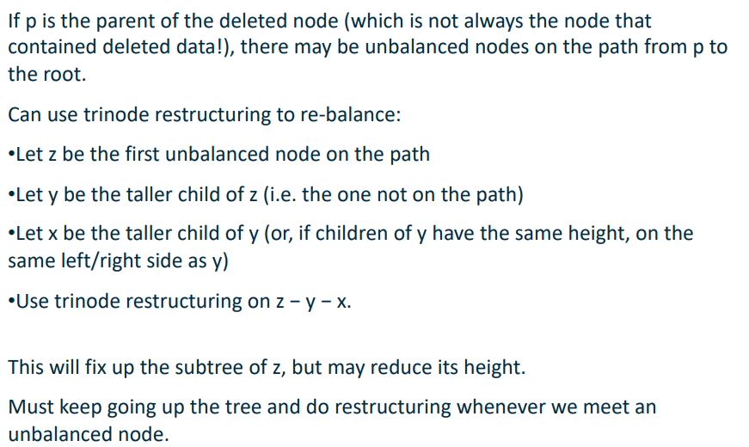
AVL Tree Deletion: can cause violations of height balance property, so we migt have to fix it up after deletion.
^ the deleted node might not always be the node containing deleted data, as if a node with two children is removed, its data is replaced by the data of the smallest node greater than the value of the deleted data, and that node is the node that is deleted.
Complexity of deletion:
Standard BST deletion is O(logn)
Fix up procedure – O(1) per level
At most once per level, with logn levels gives O(logn)
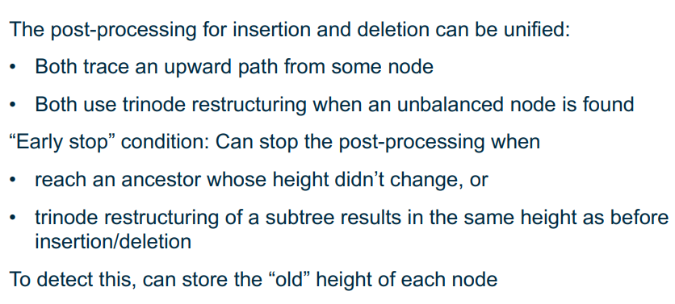
Therefore, overall worst case time is O(logn)
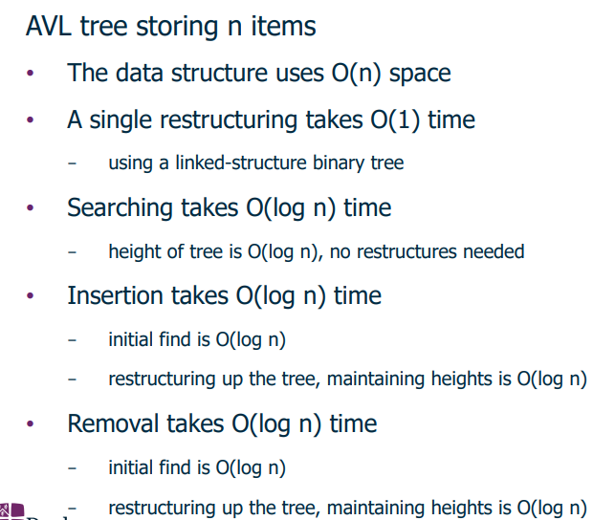
AVL Tree Performance:

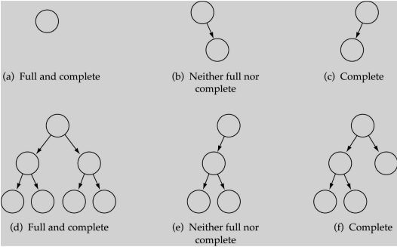
Heaps
BSTs and family are “proper” tree structures – have 0,1 or 2 children.
Heaps are also trees, but usually assumed to be stored as an array.
- Physically a linear array
- Logically as a binary tree, filled on all levels except the lowest.
Each tree node corresponds to an element in the array, and the tree is complete, perhaps except the lowest level (unless there is the exact amount of data to perfectly fill a set number of levels), filled left to right.
Heaps are very much NOT BSTs, they are not in the BST order.
Types of heap:
- Max-heap – for every node excluding the root, the value of that node is less than or equal to that of its parent. This means the root is the largest element in the tree. In any subtree, no values in the subtree are larger than the subtree root.
- Min-heap – For every node excluding root, value of the node is greater than or equal to the root, i.e opposite of maxheap.
Heap properties:
- Is a complete binary tree
- The value stored at node is >= values stored at children (for max heaps, opposite true for minheaps)
Heaps can be represented as an array A with 2 attributes ->
- Length(A) = number of elements in A
- HeapSize(A) = number of elements in heap stored in A
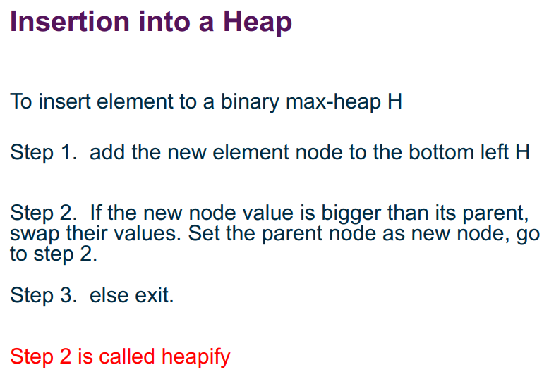
Need Length(A) >= HeapSize(A) at all times; height of heap tree = floor(logn)
^ just keep recursively swapping node with its parent until its correct

Array indices of elements in a heap (assuming array 1-indexed (ew)):
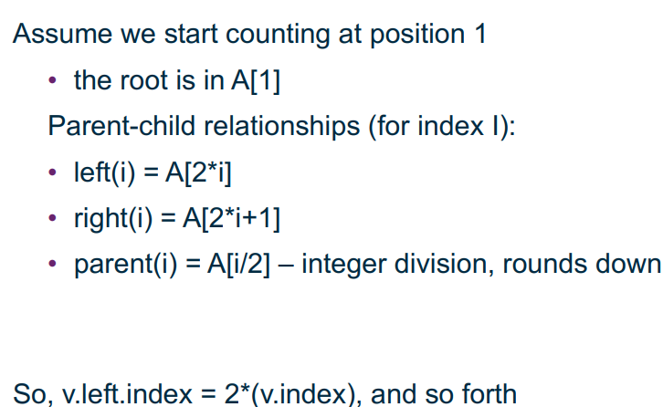
E.g.:

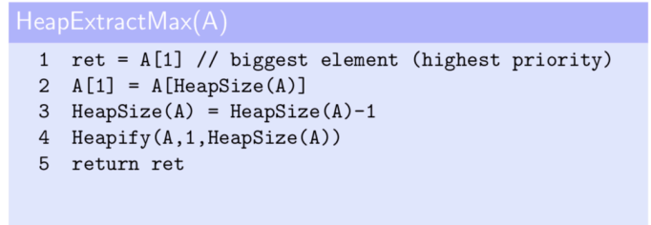
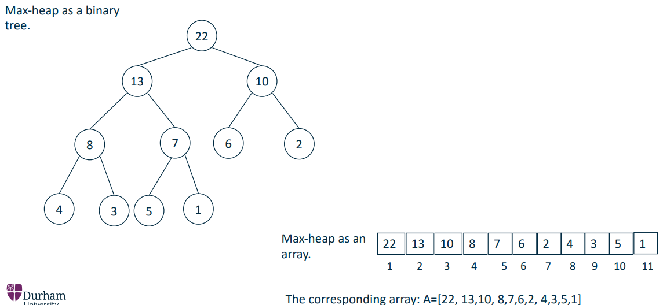
Heaps are good data structures for priority queues and for sorting. Given a sequence of objects with different priorities, want to deal with the highest priority item first. We can extract maximum element quickly from a heap – its just the first element in the array:
This can be done in O(1) time, excluding time taken for heapification – once the root node has been yoinked, it needs to be replaced. We replace it with the last element (as we need to replace it with a node with no children otherwise we would have to recursively heapify) and then heapify it to maintain the maxheap properties.

Heapification – turning a binary tree into a heap:
- starting at the root, identify largest of current node v and its children.
- . suppose largest element is in index w
- If w ≠ v:
1. swap A[w] and A[v]
2. recurse into w (contains now what root contained previously)
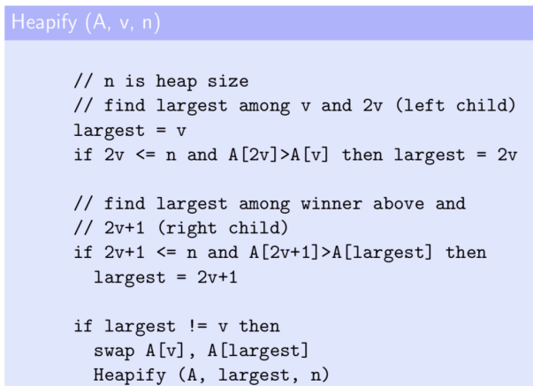
(basically recursively swapping the largest element in a subtree with its root to maintain the maxheap property)
Running time: linear in height of tree, so O(logn) where n is number of elements in tree. The comparison statements take constant time, and it recurses maximum 2h times, where h = floor(logn) hence O(logn)

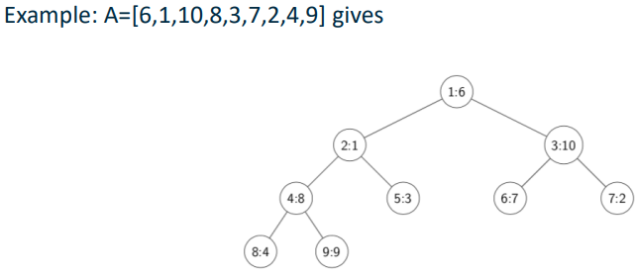
BuildHeap function: convert an array A of arbitrary numbers into a heap.
(7:2 means that the value of 2 is stored in position 7 of the array – its 1-indexed )
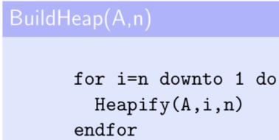
We want to start from the bottom and build up by repeatedly calling the Heapify function.
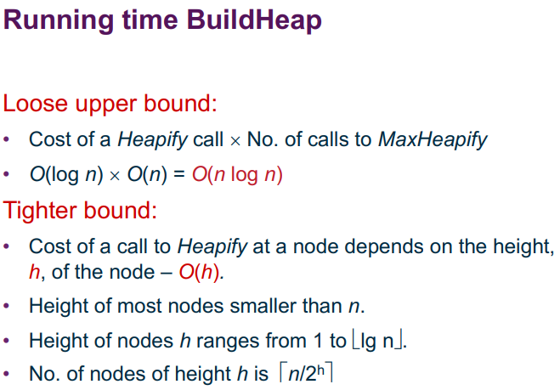
Note: this code does excess work in that it calls Heapify on the leaf nodes, which have no children and so the Heapify will not be able to do anything, but it does increase running time.

< n elements to call Heapify on; Heapify is O(logn)

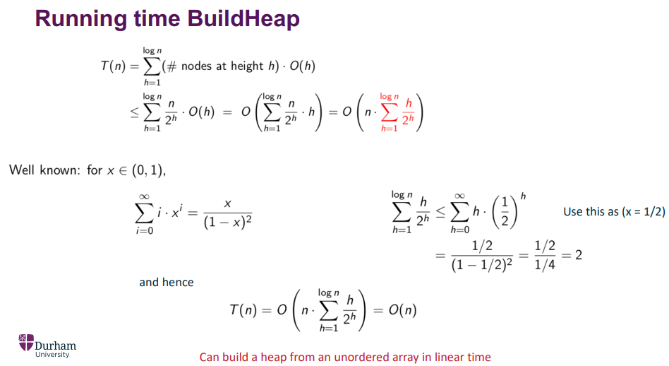
Random math bullshit, go!
^its actually O(n) now apparently

Deletion from a Heap:
An element is always deleted from the root. Replace the root node’s value with the last node’s value (last node = rightmost bottommost node; the node before where a future node would be inserted), then delete the last node. Move the new root node down by repeatedly interchanging it with the value of its largest child until it satisfies the maxheap property (i.e. repeatedly heapify).
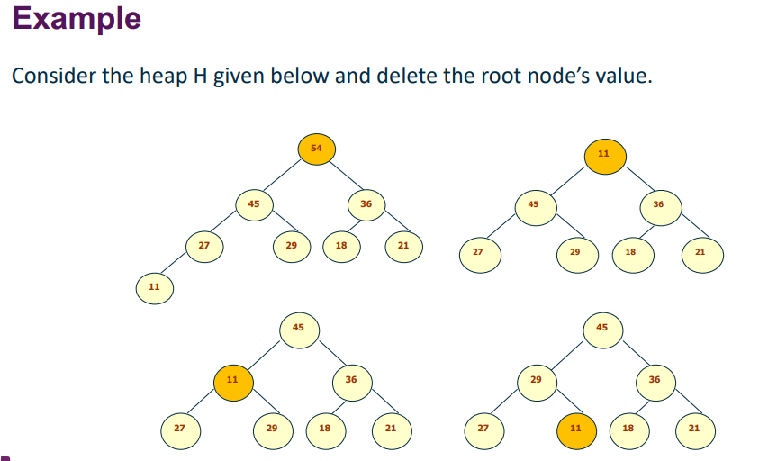
HeapSort:
Repeat the following steps until the heap contains only one element:
- Swap the root element of the heap (which is the largest element in current heap) with the last element of the heap.
- Remove the last element of the heap (which is now in the correct position). We mainly reduce heap size but DO NOT remove element from the actual array.
- Heapify the remaining elements of the heap to maintain the maxheap property.
The resulting array will be sorted (hence why we don’t remove them from the array), as the largest element keeps getting moved to the last element of the heap, i.e. the n^{th} largest element gets placed into the n^{th} rightmost position in the array, and then the heapSize is decremented to prevent these rightmost n positions from being altered by the remaining heap operations.
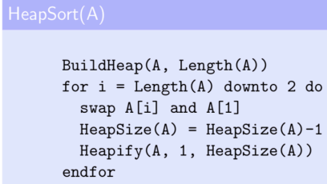
This has running time O(n) + n * O(logn) -> O(nlogn)

Lower Bounds for sorting:
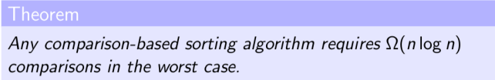
Decision trees:
A decision tree is a full binary tree (either 0 or 2 children per node) representing comparisons between elements performed by a particular algorithm on an input of size n. Note: only comparisons matter here, other operations are ignored.
Internal nodes are labelled i : j for 1 <= i, j <= n, meaning elements with indices i and j are compared.
Downward edges labelled “<=” or “>” depending on the outcome of the comparison between i and j
Leaves are labelled with some permutation of {1,…,n}. A branch from root to leaf described a sequence of comparisons that ends in some resulting sequence (i.e. the permutation represented by that leaf, where each {1,…,n} represents the indices of the elements of the unsorted input)
We have at least n! leaves.
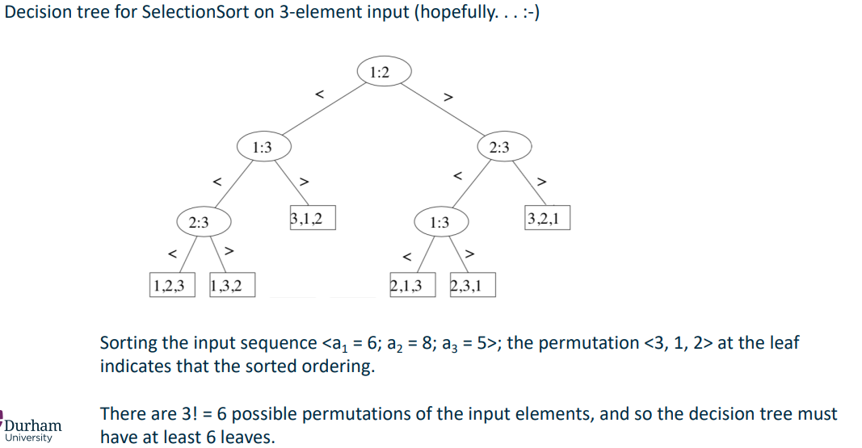
Example: SelectionSort with 3 elements:
Any correct sorting algorithm must be able to produce all possible permutations of the input array {1,…,n}, i.e. needs to sort any combination of input of size n. This means that each of the n! combinations should appear in the decision tree.
Lower bound for worst case: length of longest path from root of decision tree to any leaf represents worst case number of comparisons for given n.
For a given n, lower bound on heights of all decision trees where each permutation appears as leaf is thus lower bound on running time of any comparison based sorting algorithm.

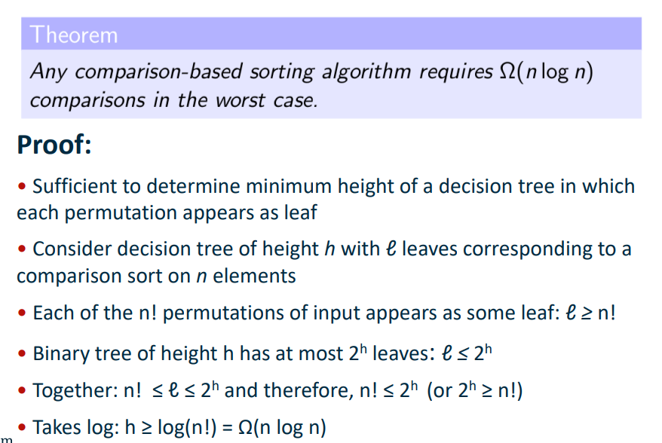
Selection and Adversaries
An adversary is a second algorithm intercepting access to the input, and gives answers that are always consistent with the input, i.e. the adversary can never be caught “cheating”. It ensures that the original algorithm has not enough info to make a decision for as long as possible. It dynamically constructs a bad input as the algorithm runs to keep the algorithm running as long as possible. It does not know what the algorithm does in future, so must work for any original algorithm.
To get a good lower bound, design a good adversary.

Example: finding max element in an unsorted array
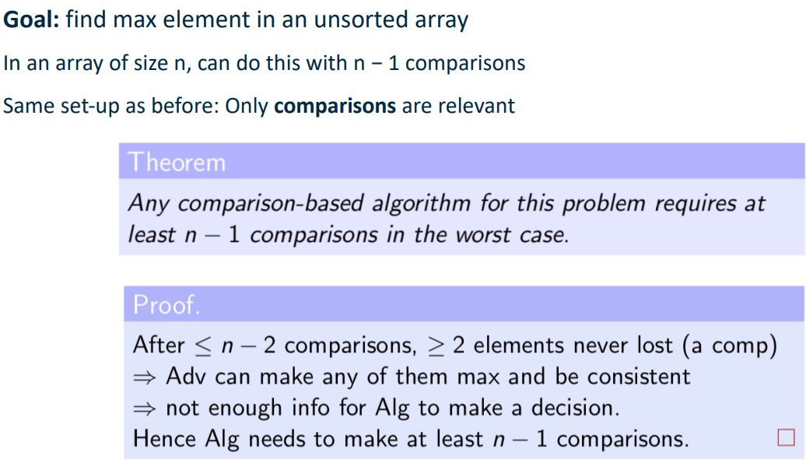
For this algorithm, the only relevant information is the number of elements that lost the comparison. The algorithm can make a decision once n-1 elements have lost – max is the one that has not lost.
Assuming each index i has a status N (never lost) or L (lost), initially all indices have status N.
After each comparison, there can be a status change from N to L. The goal of the adversary would be to delay the changes from N-L as much as possible.
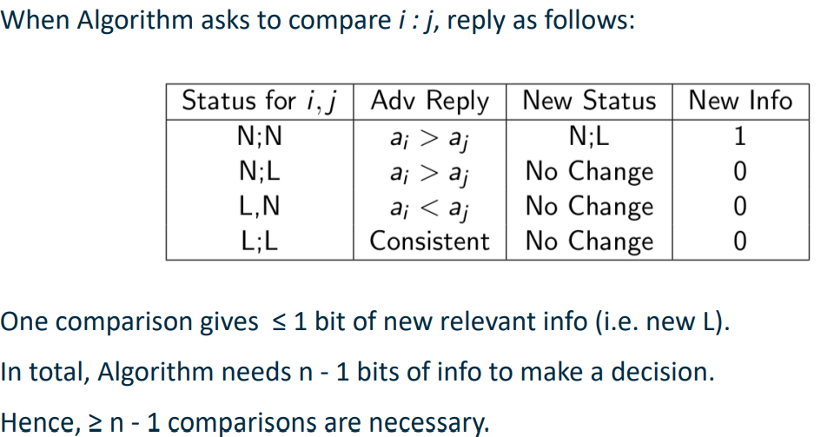
^ the 1 in New Info represents that 1 bit of new relevant info has been discovered.
This adversary only produces a status change when it absolutely has to, otherwise maintaining the status quo when that is a possibility that is consistent with the input.

Example 2: find second largest element in unsorted array
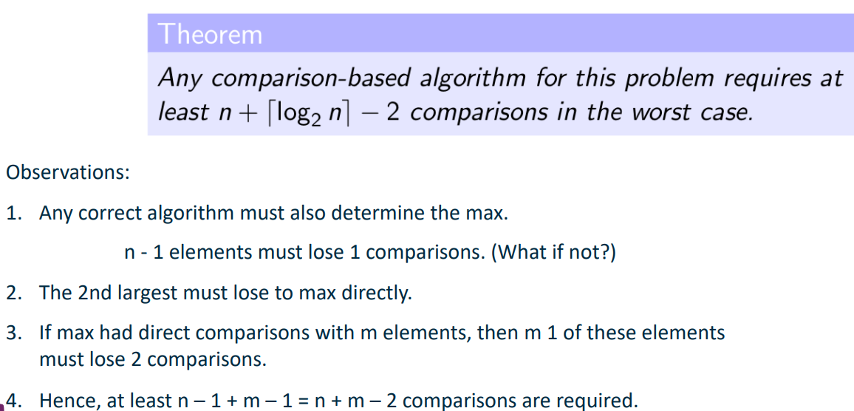
The point of the adversary is to find the minimum number of comparisons needed for the algorithm to work on any input of size n, by dynamically producing a worst case input.
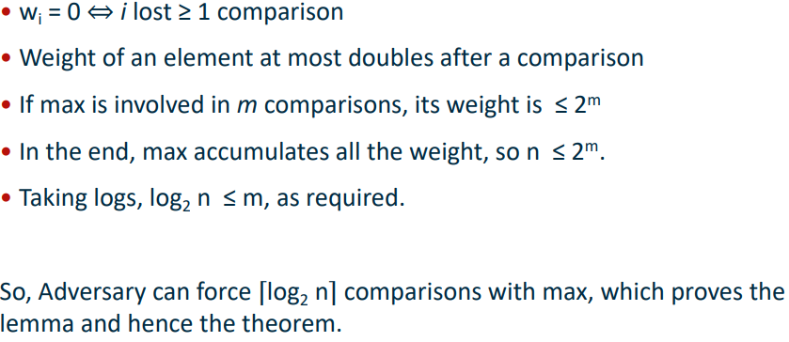
Adversary strategy:
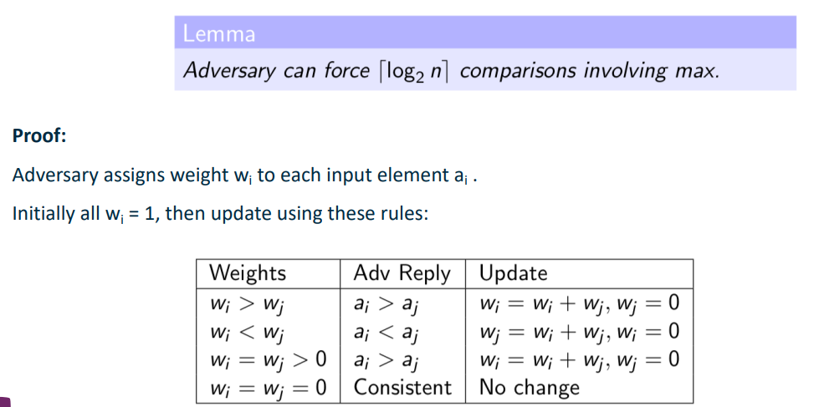
.
Algorithm for finding 2nd largest element -> uses binary tree

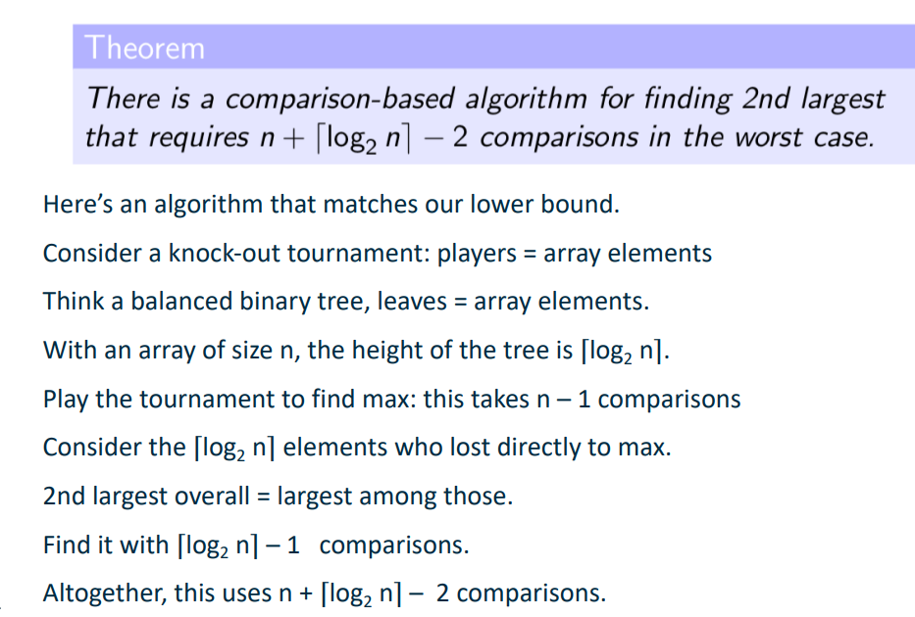
To generalise for k^{th} largest:
Let V(n,k) be the number of comparisons needed to find the kth largest element in an array of size n. he exact value of V(n,k) is known only for k=1,2,n,n-1. For other k, only some bounds can be derived:
